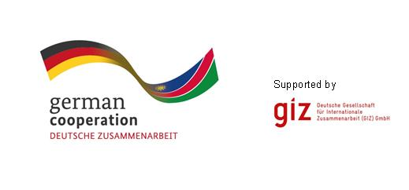
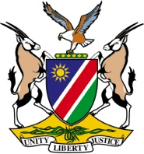

TENDER INVITATION FOR

Development of a set of critical thematic areas and indicators for Namibia’s Second National Integrated State of the Environment Report

The Sustainable Development Advisory Council (SDAC) was established in 2013 in line with section four of the Environment Management Act No. 7 of 2007. The SDAC promotes co-operation and coordination on environmental issues relating to sustainable development and provides advisory services to the Minister of Environment and Tourism with particular focus on environment-related legislation, policy and compliance measures.

Within the focal area of “Natural Resources Management”, the German Government provides support to strengthening the management capacity of Namibian institutions in the land, water, and environment sectors. This support includes the “Biodiversity Management and Climate Change” (BMCC) Project, which is implemented through the Germany Agency for Technical Co-operation (GIZ) and the Ministry of Environment and Tourism (MET).

In light of the above, the GIZ, through the BMCC Project, is supporting the SDAC to elaborate Namibia’s Second Integrated State of the Environment Report (ISOER), and hereby invites eligible and professional companies or consulting firms with relevant experience to submit tenders for the:

- Development of a set of critical thematic areas and indicators to form the basis of Namibia’s Second National Integrated State of the Environment Report.

The nature of the required services is described in detail in the Terms of Reference and related documents, copies of which are obtainable from the address and email indicated below.

Closing date for applications is 17.00 Monday 8th December 2014. If you are interested, please request the terms of references and submit your technical and financial proposal in separate sealed envelopes to the following address: Ananias Sheya, GIZ-Office Namibia, P.O. Box 8016, 88, John Meinert Street, Windhoek West. Email: ananias.sheya@giz.de

